Experiment - 2
Compilation Stages of a C Program to Find the Area of a Circle
Name: Aryan Pathak | SAP ID: 590033176
Programme: B.Tech CSE | Year: 1st Year | Batch: 16
Department: Computer Science and Engineering | Submitted to: DR. christalin Nelson

Writing the C Program
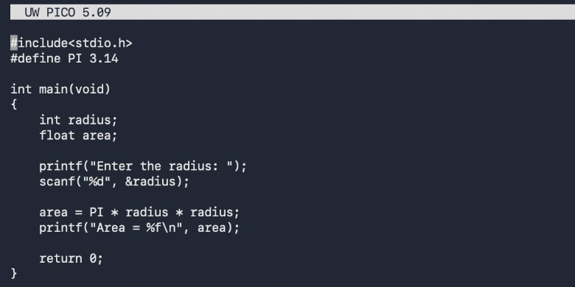
The file radius.c is open in the Pico editor. It includes the standard input/output header, reads an integer radius, calculates the area using 3.14 x radius x radius, and prints the result.

Compiling and Running
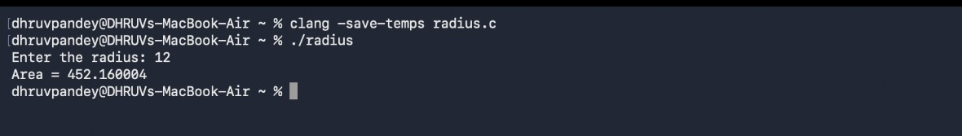
The terminal shows the program being compiled and executed. Radius 12 is entered, and the program prints Area = 452.160004, confirming that it runs successfully.

Viewing the Preprocessed Program
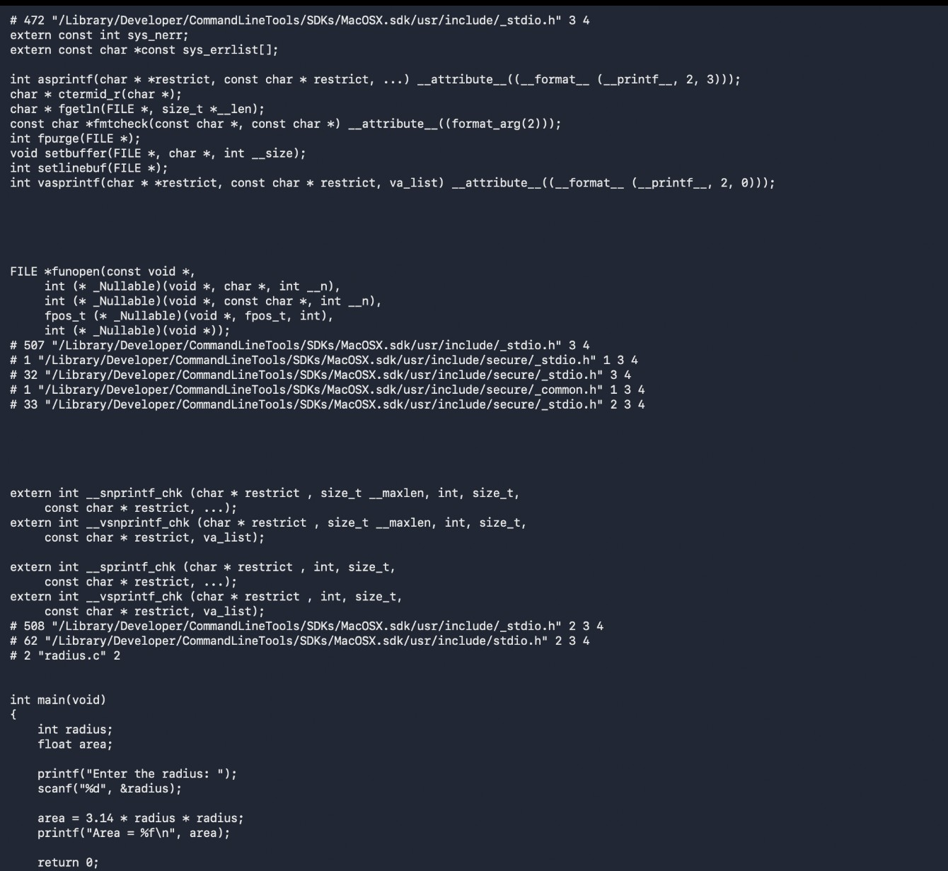
This view shows the code after preprocessing. The contents required from stdio.h are inserted, and the macro PI in the calculation is replaced by its value 3.14 before compilation.

Viewing the ARM64 Assembly
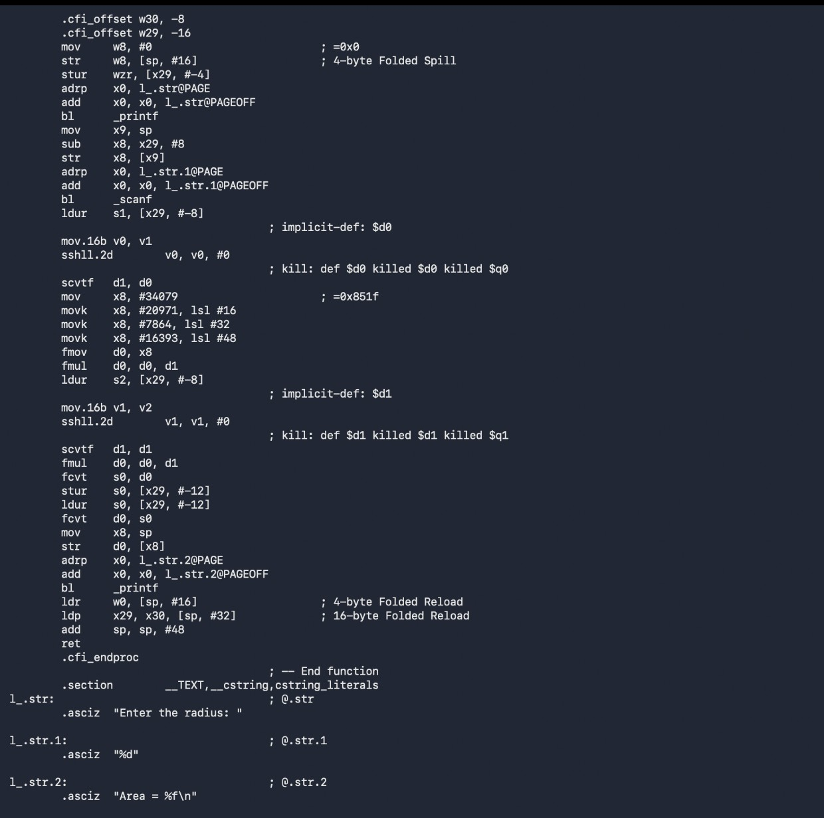
Clang has translated the C program into ARM64 assembly for the Mac. These instructions prepare the printf and scanf calls, perform the area calculation, store the result, and return from main.

Creating the Object File
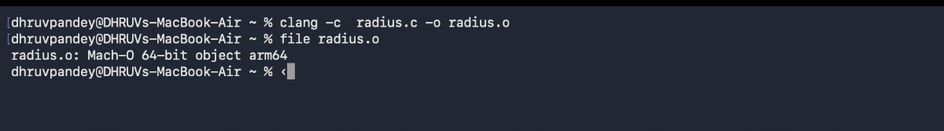
The command clang -c radius.c -o radius.o creates machine code without linking. The file command identifies radius.o as a 64-bit Mach-O ARM64 object, confirming successful object-file generation.

Result
The terminal views show the complete flow from C source code to execution, preprocessing, ARM64 assembly, and object code. The experiment was completed successfully.

